1. **New workflow for LD Adjustment handling**
   1. Add checkbox in front of LD information (records from table ld_code). Add button called “LD Adj.” in front like below screen). New button will open to a new page

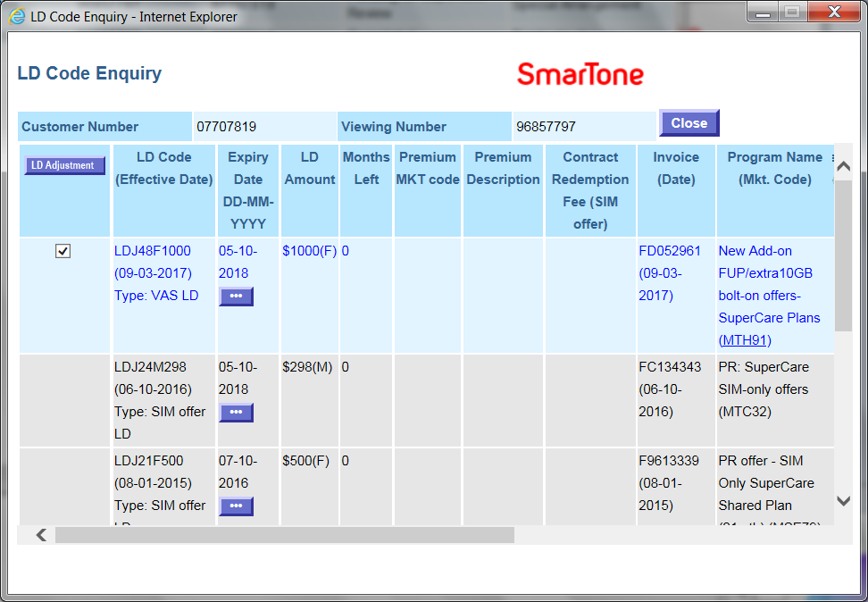

* 1. For those checked records, passing the invoice numbers as input parameter into the new page. Under new page, based on invoice numbers, retrieve related LD information to display in left hand side of the page (like below screen). On right hand side (like below screen), several fields will be needed.

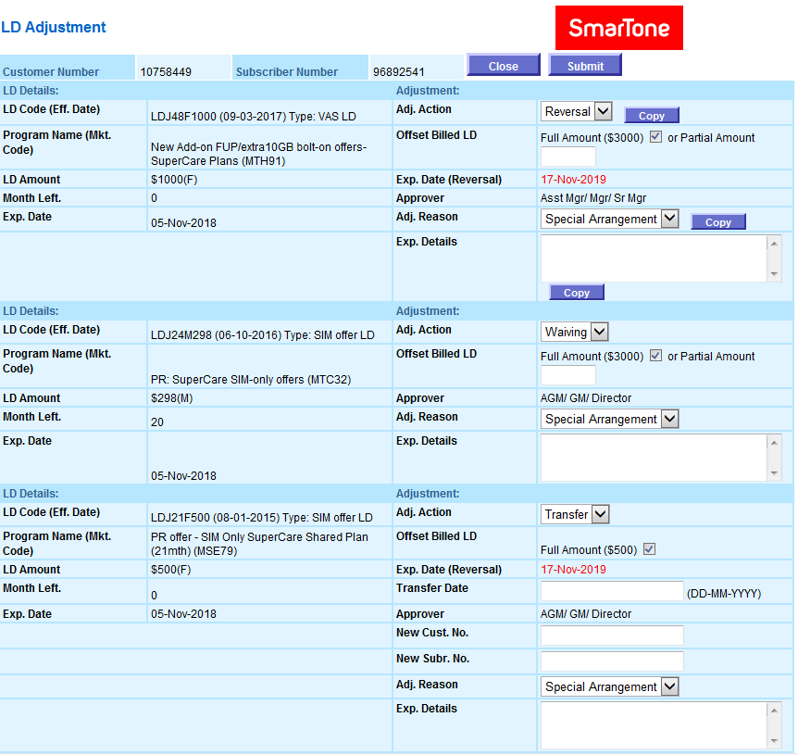

1. Field “Adj. Action” will have three selections named “Reversal”, “Waiving” and “Transfer”. On the first LD record, display like above to have button “Copy”. Click the button to copy the adj. action value into another records.
2. Field “Offset Billed LD Penalty”
   1. For Transfer action, display checkbox (Default clicked) with title “Full Amount $XXXX”. Amount will be displayed (retrieved from ld_code.billed_amt)
   2. For Waiving and Reversal action, not only display checkbox (Default clicked) with title “Full Amount $XXXX” but also “Partial Amount” with text box (support numeric only). If checkbox is clicked, disable text box and empty the value. If checkbox is un-clicked, enable text box and allow user to input.
3. Field “Exp. Date”
   1. Only display in Reversal and Transfer action (calculation of the date will be provided later)
4. Field “Transfer Date”, “New Cust No”, “New Mobile No”
   1. Only display in Transfer action
   2. Mandatory field
5. Field “Adj. Reason”
   1. Selection box: value come from table adj_code_ref where rec_type = ‘R’ and stat = ‘A’ order by order_display
   2. On first LD record, display “Copy” button to allow copy the selected value into other records if clicked.
6. Field “Explanations Details”
   1. Textarea field.
   2. On first LD record, display “Copy” button to allow copy the input value into other records if clicked.
7. Field “Approver”
   1. (calculation of the Approver will be provided later)
   2. Save the form
8. Save the record into tables after submitting the form and passed the validation.
   1. adj_ld_form_hdr
   2. adj_ld_form_subr
   3. adj_ld_form_dtl
9. Call up Adjustment Form API(s) to create adjustment case
   1. Use eadj_form.adj_gen_no to generate adjustment form number for each record
   2. Call up eadj_form.ins_form_hdr, eadj_form.ins_form_subr, eadj_form.ins_form_item with below input parameter value
      1. eadj_form.ins_form_hdr:
         1. form_no: generate from eadj_form_adj_gen_no
         2. ver_no: 0
         3. source_ref: “LD_ADJ”
         4. order_seq: adj_ld_form_hdr.order_seq
      2. eadj_form.ins_form_subr:
         1. form_no: generate from eadj_form_adj_gen_no
         2. ver_no: 0
         3. cust_num: adj_ld_form_subr.cust_num
         4. subr_num: adj_ld_form_subr.subr_num
      3. eadj_form.ins_form_item:
         1. form_no: generate from eadj_form_adj_gen_no
         2. ver_no: 0
10. Call up CCS Hold Form API to create hold form case (ccs_form.ins_act_form) with below input parameter value:
    1. custNum
    2. subrNum
    3. holdBar
    4. debarFirst
    5. holdObx
    6. holdDiscon
    7. holdDate
    8. reasonType
    9. holdReason
    10. requestBy
    11. contactNo
    12. replyFl
    13. replyCcs
    14. handleBy
    15. salesman
    16. bypass
    17. source
    18. Printout LD Adjustment Form
11. If Adj. Action related to “Transfer”, LD Adjustment Form is needed to printout. (Printout form will be provided later)
12. **APIs for adjustment form creation**
    1. eadj_form.ins_form_hdr
       1. input parameters
          1. form_no
          2. ver_no
          3. reason_code
          4. reason_desc
          5. status
          6. urgent_ind
          7. explain_dtl
          8. next_group_id
          9. next_appr_id
          10. sugg_appr_id
          11. subr_type
          12. attach_pg_no
          13. handle_by
          14. salesman
          15. source_ref
          16. order_seq
       2. workflow
          1. Validate input value of reason_code exist in table adj_code_ref and rec_type = ‘R’, if not, return failure
          2. Validate input value of next_group_id, it should be same as value of rec_content in table adj_parameter_ctrl and rec_type = ‘ACTION_PARTY_GROUP’, except “0”. If not, return failure
          3. Based on input value, insert record into table adj_form_hdr
       3. output parameters
          1. result_code
          2. result_msg
    2. eadj_form.ins_form_subr
       1. input parameters
          1. form_no
          2. ver_no
          3. cust_num
          4. subr_num
          5. status
          6. next_group_id
          7. account_manager
          8. team
          9. remarks
       2. workflow
          1. Based on input value, insert record into table adj_form_subr
       3. output parameters
          1. result_code
          2. result_msg
    3. eadj_form.ins_form_item
       1. input parameters
          1. form_no
          2. ver_no
          3. item_code
          4. input_value_01
          5. input_value_02
          6. input_value_03
          7. input_value_04
          8. input_value_05
          9. input_value_06
          10. input_value_07
          11. input_value_08
          12. input_value_09
          13. input_value_10
          14. input_value_11
          15. input_value_12
          16. input_value_13
          17. input_value_14
          18. input_value_15
          19. input_value_16
          20. input_value_17
          21. input_value_18
          22. input_value_19
          23. input_value_20
       2. workflow
          1. Validate input value of item code whether exist in table adj_item_ref and cross checking with mandatory_XX and input_value_XX whether has value provided. If not, return failure.
          2. Based on input value of item code, mapping with adj_item_ref and adj_group_ref, construct the content with English and Chinese wordings then insert into field content and content_chi.
          3. Insert record into table adj_form_item
       3. output parameters
          1. result_code
          2. result_msg
13. **Revise Get Adjustment Approval function for handling LD Adjustment**
    1. Will provide later
14. **Revise Get Adjustment Case function for handling LD Adjustment**
    1. Will provide later
15. **Revise CCS Hold Form**
    1. Will provide later

Programs to be changed:

1. /src/fes/cs/ld/LdContract.java
2. /jsp/fes/cs/ld/LdEnquiry.jsp
3. /src/fes/eform/eadj/EADJLDHandler.java (New java program path)
4. /jsp/fes/eform/eadj/EADJLD*.jsp (New jsp program path and prefix)
5. EADJ_FORM.pks (CRM DB)
6. EADJ_FORM.pkb (CRM DB)